High Level Design (HLD)

Flight Fare Prediction

Harsha MS

**Document Version Control:**

|  |  |  |  |
| --- | --- | --- | --- |
| Date Issued | **Version** | **Description** | **Author** |
| 19th October 2022 | **1** | **Initial HLD-V1.0** | **Harsha MS** |
|  |  |  |  |
|  |  |  |  |
|  |  |  |  |
|  |  |  |  |

**Contents:**

Document Version Control--------------------------------------------------------------2

Abstract-------------------------------------------------------------------------------------4

1 Introduction------------------------------------------------------------------------------5

1.1 Why this High-Level Design Document-----------------------------------5

1.2 Scope--------------------------------------------------------------------------- 5

1.3 Definitions---------------------------------------------------------------------5

2 General Description---------------------------------------------------------------------6

2.1 Product Perspective----------------------------------------------------------6

2.2 Problem Statement------------------------------------------------------------6

2.3 Proposed Solution-------------------------------------------------------------6

2.4 Further Improvements--------------------------------------------------------6

2.5 Technical Requirements------------------------------------------------------6

2.6 Data Requirements------------------------------------------------------------7

2.7 Tools Used---------------------------------------------------------------------8

2.8 Constraints---------------------------------------------------------------------9

2.9 Assumptions-------------------------------------------------------------------9

3 Design Details---------------------------------------------------------------------------9

3.1 Process Flow-------------------------------------------------------------------9

3.1.1 Model Training and Evaluation----------------------------------10

3.1.2 Deployment Process-----------------------------------------------10

3.2 Event log----------------------------------------------------------------------11

3.3 Error Handling---------------------------------------------------------------11

4 Performance----------------------------------------------------------------------------12

4.1 Reusability--------------------------------------------------------------------12

4.2 Application Compatibility--------------------------------------------------12

4.3 Resource Utilization---------------------------------------------------------12

4.4 Deployment------------------------------------------------------------------12

5 Conclusion-----------------------------------------------------------------------------13

6 References------------------------------------------------------------------------------13

**ABSTRACT**

The recent changes in the international market had a large impact on the Aviation sector because of several reasons. These impact the two class folks, the first is Business perspective and second is Customer perspective. The major reason for such an impact is the governments around the world amended totally different rules to their various Airline firms. Taking these factors into consideration, the value of the flight tickets has varied from one place to another. Booking a flight ticket has its price tag split into two, one is online bookings and other is offline bookings. Each of these have their various criteria for value of the price, one such example is the server load and therefore the range of booking requests. During this machine learning implementation, we are going to see numerous factors that impact the price of the flight ticket and predict the acceptable price of the ticket.

1. **INTRODUCTION**
   1. **Why this High-Level Design Document?**

The purpose of this High-Level Design (HLD) Document is to add the necessary details to the current project description to represent a suitable model for coding. This document is also intended to help detect contradictions prior to coding, and can be used as reference manual for how the modules interact at a high level.

**The HLD will**

• Present all of the design aspects and define them in detail

• Describe the user interface being implemented

• Describe the hardware and software interfaces

• Describe the performance requirements

• Include design feature and the architecture of the project

• List and describe the non-functional attribute like:

• Security

• Reliability

• Maintainability

• Portability

• Reusability

• Application compatibility

• Resource utilization

• Serviceability

* 1. **Scope**

The HLD document presents the structure of the system, such as the database architecture, application architecture (layers), application flow (Navigation), and technology architecture. The HLD uses non-technical to mildly-technical terms which should be understandable to the administrators of the system.

* 1. **Definition**
* FFR – Flight Fare Prediction

1. **GENERAL DESCRIPTION**
   1. **Product Perspective**

The flight fare prediction may be a machine learning model that helps users to predict the price of the flight tickets and help them to understand the price of their journey.

* 1. **Problem Statement**

After amendment of the new rules, there are changes in the flight fare price from one location to another. The main goal of the system is to create a model to predict the price of their flight fare on the basis of bound input provided by users like date of journey, Source, Destination and many more.

* 1. **Proposed Solution**

To solve the problem, we have created a user interface for taking the input from the user to predict the flight fare price using our trained ML model after processing the input and at last the output (predicted value) from the model is communicated to the user.

* 1. **Further Improvements**

We also analysed the data used for training the ML model by considering different occasions such as Weekday, Season or any Social reasons, considering different angles of business. If we use such information and predict the discounted flight fare price, it will bring some loss to the airline companies but users can benefit from that. If we develop these using the Business perspective of Airline, this technique isn’t thought - about.

* 1. **Technical Requirements**

As technical requirements, we don't need any specialized hardware for virtualization of the application. The user should have a device that has the access to the web and the fundamental understanding of providing the input. And for the backend, we need a server to run all the required packages to process the input and predict the desired output (predicted flight fare price).

* 1. **Data Requirements**

The Data requirements totally supported the matter statement and also the dataset is accessible on the Kaggle within the file format of (.xlsx). Because the main theme of the project is to induce the expertise of real time issues, we have a tendency to transform the information into the prophetess database and commerce it into csv format.

* 1. **Tools Used**

Python programming language and frameworks such as NumPy, Pandas, Scikit-learn, Matplotlib, Flask etc are used to build the whole model.







• Virtual Studio Code is also used as IDE

• For visualization of the plots, Matplotlib, Seaborn and Plotly are used.

• AWS is used for deployment of the model.

• Heroku is also used for deployment of the model.

• Cassandra database is used DB operations

• Python, Flask is used for backend development

• GitHub is used as Version Control System.

* 1. **Constraints**

The flight fare prediction answer should be user friendly, as automatic as attainable and also the user should not be needed to understand any of the operations.

* 1. **Assumptions**

The main objective of the project is to implement the utile cases for the new dataset that provides the user the ability to predict Flight Fare Price. Machine learning model is employed for process the user input for prediction. It additionally assumed that each one aspects of this project have the flexibility to figure along within the approach the designer is expecting.

1. **DESIGN FLOW**
   1. **Modelling Process**

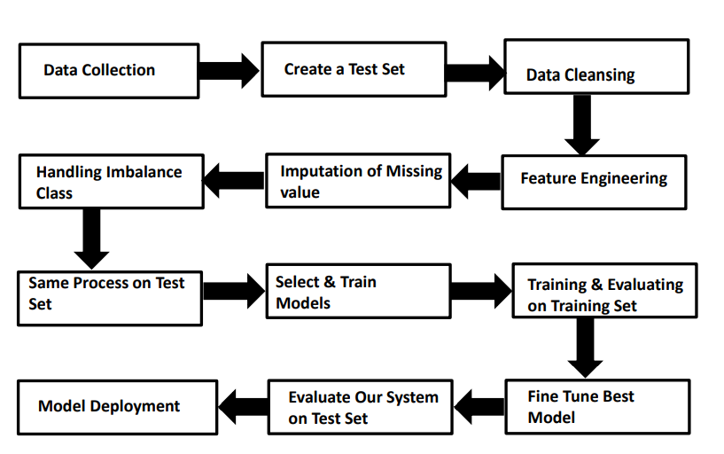

* 1. **Deployment Process**

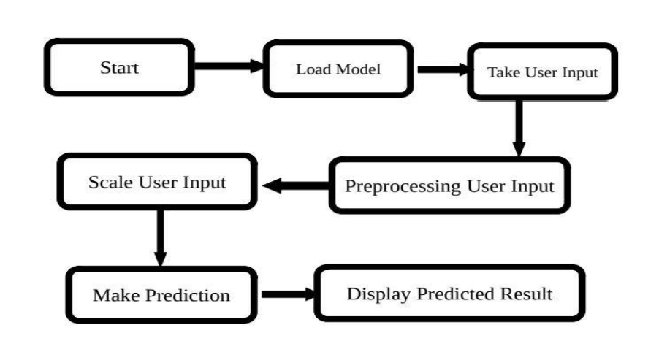

* 1. **Event log**

In logging, each time an error or an exception occurs, the event is logged into the system log file with reason and timestamp. This helps the developer to debug the system bugs and rectify the error.

* 1. **Error Handling**

Once the error occurs, the reason is logged into the log file with timestamp to rectify and handle it.



1. **Performance**
   1. **Reusability**

The code written and the components used should have the ability to be reused with no problems.

* 1. **Application Compatibility**

The different parts of the system are communicating or using Python as an interface between them. All the components have its own tasks to perform and it is the job of a Python to ensure proper transfer of data.

* 1. **Resource Utilization**

When a task is performed, it’ll doubtless use all the process power offered till the process is finished.

* 1. **Deployment**

The model can be deployed using any cloud services such as Microsoft Azure, Amazon web services, Heroku, Google cloud, etc.

1. **CONCLUSION**

The Flight Fare Prediction system will predict the price for helping the customers with the trained knowledge with set of rules. The user can use this system to recognize the approximate value of its flight fare for his or her journey.